**Database Backup Automation**

**Condition:** No direct access to database host but provided with connection details

1. Download SQL Package (Communication between sql server studio and python)

Extract sql package to disk c and create folder called customtools under c:/

1. Run a python script to backup.

import subprocess

import datetime

import os

def export_bacpac():

backup_dir = "C:\\Backups"

os.makedirs(backup_dir, exist_ok=True) # Ensure the folder exists

timestamp = datetime.datetime.now().strftime("%Y%m%d_%H%M%S")

output_path = os.path.join(backup_dir, f"GSDM-Copy-IGS_{timestamp}.bacpac")

command = [

"C:\\customtools\\sqlpackage\\sqlpackage.exe",

"/Action:Export",

"/ssn:dev1epms.database.windows.net",

"/sdn:GSDM-Copy-IGS",

"/su:dev1user",

"/sp:dev1@emps@db",

f"/tf:{output_path}"

]

result = subprocess.run(command, capture_output=True, text=True)

if result.returncode == 0:

print(f"[✔] Export successful: {output_path}")

else:

print("[✖] Export failed")

print("STDOUT:", result.stdout)

print("STDERR:", result.stderr)

export_bacpac()

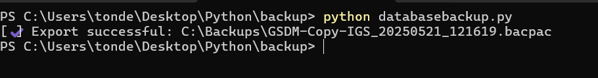

1. Create a bat file for your python folder and store it next to python script

@echo off

REM Adjust python path if needed or use python from PATH

python "C:\Users\tonde\Desktop\Python\backup\databasebackup.py"

1. Create a Task Scheduler task and select the .bat file to run the backup automatically. Set the trigger.
2. Sync the download folder with Google Drive or Blob Storage.